ROW Parcels Summary
The MDL application: RD_ROWParcels
This MDL application is used to extract parcel name and number data from the Microstation design files and write it to an ASCII text file.

Startup
Start by typing 'MDL L RD_ROWPARCELS', or by using the Parcel Index Application icon on the RD_MDLapps toolbox. | 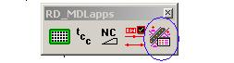

On startup, the program will prompt you for the output text file name. If you're starting a new file, just enter a name for the file.
If you have previously used the program and are re-opening the output file to add new parcels, the program will not allow you to select the existing file. Furthermore, if you enter the name of an existing file, the program will ask you if you want to overwrite the file. | 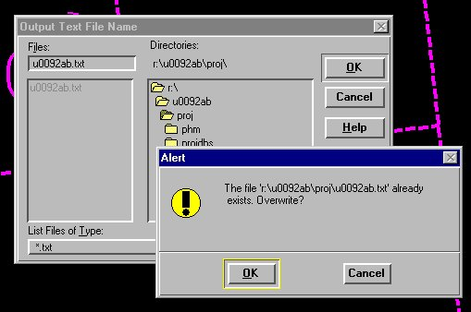
Read this:>When you need to re-open a file for appending, click on OK to overwrite the file. Know that the file will not actually be overwritten, it WILL append new parcel information.
If you want to know why the program acts so stupid, read the following.
The file open/create portion of the program is using standard Microstation MDL file functions. These MDL file functions do not provide a seamless method of opening an external file for appending. This functionality has to be built into the program the long hard way. I decided it wasn't worth it. So, there ya go.

Collecting Parcel Information: The Input Cycle
The RD_ROWParcels program allows you to enter parcel names and numbers for collection by element selection.
When the program is ready to begin the selection process, the Parcel Name text field is highlighted, and the Microstation prompt provides directions. | 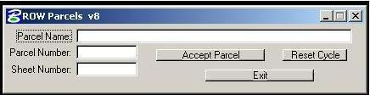  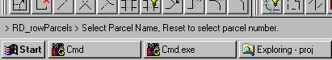
Select the parcel name by clicking on the text node. The text is picked up and placed in the Parcel Name text box. You may select as many text nodes as necessary, each one will be appended to the Parcel Name displayed.  When you're ready to select the Parcel Number, click Reset. | 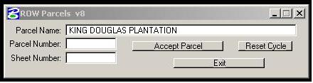
Select the corresponding Parcel Number text node. The number text is transferred to the Parcel Number text field on the dialog.
At this point, you may enter the plan sheet number, if the currently displayed number is no longer correct. | 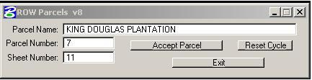
When all three text fields are filled in, click on Accept Parcel to write the parcel information to the output text file.
The dialog will reset to the beginning of the cycle, ready for selection of the next Parcel Name.
Note: At any time, if you're unsure which step of the cycle you're at, click on the Reset Cycle button. This will set it to the beginning of the cycle: Parcel Name input. Any parcel data loaded and not written to the file will be dumped.
Upon completion of collecting the parcel information and writing it to an ASCII text file you will then proceed to the next step of placing it into the Excel template spreadsheet file the Parcel Index Sheet for formatting, editing and plotting the summary information.

